
Russell Dillwyn, VA
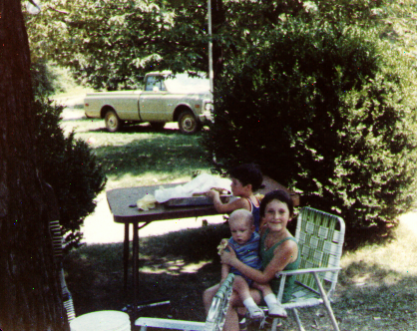
Lisa, Russell, Kevin Dillwyn, VA
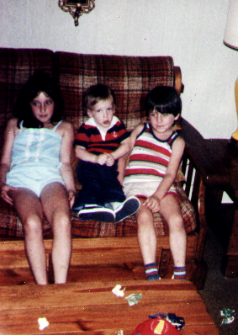
Lisa, Russell, Kevin Dillwyn, VA
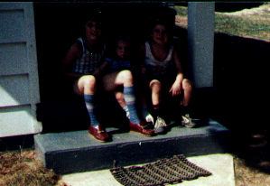
Lisa, Russell, Kevin Dillwyn, VA

